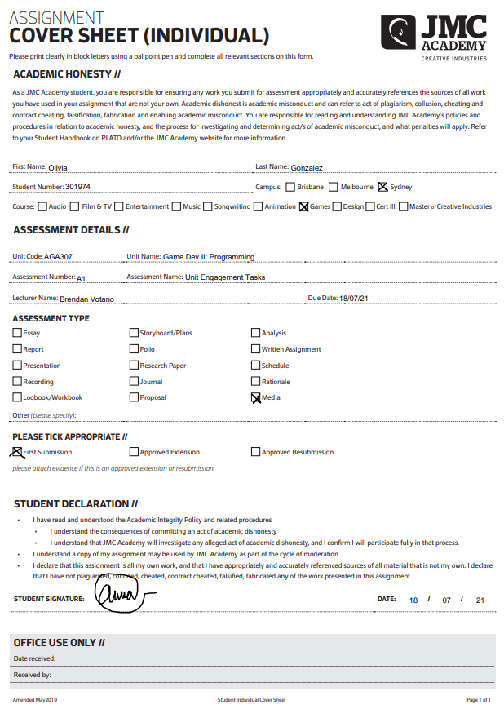

**Weekly Recording**

*Requirements and Challenges*

***9th June 2021***

**Requirements**

* Created Unity File
* Basic Character Movement
* Jumping
* Camera Clamping
* Mouse Lock

**Challenges**

* Use ProBuilder to make a basic scene.

***16th June 2021***

**Requirements**

* Github Setup & Push
* Projectile (Firing, Destroyed OnCollision with Target, Destroy)
* Target Set up (Destroy when hit by projectile)
* Trigger Zone // Change Sphere – When exiting, revert sphere property.
* Sphere property change (scale and colour)

**Challenges**

* Targets have hit points (require multiple hits to destroy)
* Second Trigger Zone // Raycast to the Sphere change a property when raycast hit is true & another property when ‘E’ key is pressed.

***23rd June 2021***

**Requirements**

* Instantiating random target at a random spawn point when the player presses “I”.

**Challenges**

* Creating a weapon select system with three different projectiles and firing them with the mouse button.
* Using 1-3 Keys to change between them (and printing the weapons name on the console)
* Displaying the weapons name on the UI

***30th June 2021***

**Requirements**

* Create a TargetManager and a Target script
* Declare an enum of target sizes and assign them.
* Use a Switch Statement to change the scale accordingly when the game starts.
* Make the Targets move using a coroutine.

**Challenges**

* Make the targets move via a coroutine to a random new position every 3 seconds.
* Move the targets by different speeds depending on its size.
* Set targets colour by its size.

***7h July 2021***

**Requirements**

* Import the Singleton Script from Plato into the Project
* Create a GameManager Script and turn it into a Singleton with a score variable.
* Turn the TargetManager into a Singleton and ensure that the targets are being removed when destroyed.

***14h July 2021***

**Requirements**

* Create a canvas with a Text Object for the score, targets left and difficulty.
* Create a UIManager as a Singleton, and get it to display the score from the GameManager (Targets Left, and the difficulty on the UI Text objects)
* Add a timer to the GameManager (Starts at 30 and counts down, add 5seconds when a target is hit and display the timer in a UItext Object)
* Create a Title screen that allows us to start the game and quit from the game. Add a logo (with student name and course code)

**Challenge**

* Text pop up for Sphere Change 2.
* ‘Esc’ Key to quit when in MainScene
* Target Movements move using linear Interpolation

https://github.com/pompom2600/O_Gonzalez_AGA307_A1